**Global Coffee Platform**

**Equivalence Mechanism revision**

**Consultation survey**

**Date: 16 March 2022**

**Introduction**

The [Global Coffee Platform](https://www.globalcoffeeplatform.org/) (GCP) is a multi-stakeholder membership association dedicated to advance coffee sustainability. GCP Members are united under a common vision to work collectively towards a thriving, sustainable coffee sector for generations to come. Members include coffee producers, traders, roasters, retailers, sustainability standards and civil society, governments and donors.

The Coffee SR Code (previously known as the Baseline Coffee Code) is a sector wide reference on the foundations of sustainability in the economic, social and environmental dimensions for green coffee production and primary processing worldwide.

The Equivalence Mechanism (EM) is a framework developed by GCP to assess whether a sustainability scheme (public, private and voluntary codes, standards and initiatives) can be considered equivalent to the Coffee Sustainability Reference Code (Coffee SR Code). It can be used by sustainability schemes and/or by supply chain actors to assess their schemes against the Principles and Practices outlined in the Coffee SR Code for self-assessment, for credibility purposes or/and to be eligible for the GCP Reporting on Sustainable Coffee Purchases. Schemes that meet both the Code and the Operational Criteria are recognized as “equivalent” by GCP.

With the recent publication of the revised Coffee Sustainability Reference Code, the Equivalence Mechanism needs to be updated to reflect the changes in the Code, as well as consider system aspects that needed further consultation from the last revision of the EM in 2020, e.g. standard setting and governance. In particular, one of the main objectives of the Equivalence mechanism revision is to review and revise the Operational Criteria to reflect current good practice and users’ expectations of credible schemes.

GCP is inviting members, non-members and any interested stakeholders in the coffee sector to provide feedback on the proposed revised draft for the Equivalence Mechanism Version 2.0.

While the Equivalence Mechanism is a reference for the assessment of sustainability schemes around baseline sustainability practices, not a standard, the EM revision follows the good practices set out in the [ISEAL Code of Good Practice for Setting Social and Environmental Standards (version 6.0).](https://www.isealalliance.org/get-involved/resources/iseal-standard-setting-code-good-practice-version-60)

For information about the rationale of the Equivalence Mechanism revision, the process, timelines and decision making please see the [Project Description.](https://www.globalcoffeeplatform.org/wp-content/uploads/2022/03/ProjectDescription-EM-2.0.pdf)

The consultation period will last 35 days from 16 March until 20 April 2022.

Please be invited to participate via the online survey that is available [in this link](https://www.surveymonkey.de/r/3YMNSND). Your input is of great value. If you have any problems filling the online survey or have any questions, please contact [info@globalcoffeeplatform.org](mailto:info@globalcoffeeplatform.org).

The revised Equivalence Mechanism will be published on Q4 2022.

All information received will be treated with care and strict confidentiality. Only aggregated results will be shared publicly.

The online version saves itself automatically so you do not need to answer all in one go and you can return to the questionnaire at a later point and even change responses, on the same device.

This survey includes a set of 14 questions in the following sections:

1. Information about your organization/company (3 questions)
2. Specific questions (7 questions)
3. General questions (3 questions)
4. General comments (1 question)

The survey covers key questions on the changes proposed to the Equivalence Mechanism. We recommend that you have a look at the following documents available [in this link](https://www.globalcoffeeplatform.org/our-work/gcp-equivalence-mechanism/#Revision) before answering the survey:

* Video that explains the background of the revision and key changes proposed
* Project description;
* DRAFT Equivalence Mechanism v2.0 proposal;
* Frequently Asked Questions;
* Excel file detailing all the changes proposed per criterion and their rationale;
* Complete consultation survey in Word.

The abbreviations used in this consultation are:

* GCP Global Coffee Platform
* EM Equivalence Mechanism
* Coffee SR Code Coffee Sustainability Reference Code
* SO Scheme Owner

**Thank you in advance for taking the time to contribute to this consultation!**

1. **Information about your organization/company**
   1. Contact information

*The information requested is for analysis purposes and for follow up/clarify answers if needed, individual responses will be strictly confidential, only aggregated results will be shared publicly*.

Name of the contact person

Name of your organization/company

Country

Email address

* 1. Stakeholder Group

Producer

Trader

Roaster/Retailer

Government

Civil Society (Non-Governmental Organization, NGO)

Other (please specify)

* 1. Are you a GCP Member?

Yes

No

1. **Specific questions**

**Claims about the GCP recognition**

The Equivalence Mechanism is composed of the Coffee SR Code (sustainability criteria) and the Operational Criteria. This consultation survey covers only aspects relevant to the Operational Criteria and the Equivalence Process.

The Equivalence process has three stages:

* Application
* Assessment of sustainability (Coffee SR Code) and Operational Criteria
* Reporting to GCP

The graphic below outlines the general steps in the Equivalence process.

This section of the survey focuses on changes to the application, the Operational criteria and the reporting of GCP. For each topic the key changes and their rationale are presented.

**Application**

The application section includes the Eligibility Criteria and Claims about the recognition. No changes are proposed to the Eligibility Criteria. The following are the changes proposed to the claims about the GCP recognition.

**Claims about the GCP recognition**

Depending on the characteristics of the scheme, the claim the scheme can make about the recognition by GCP differs. To differentiate between the different models of assurance, GCP classifies the scope of the assessment as follows. During the application process the scheme needs to select for which claim is applying for:

* GCP recognized schemes as equivalent 3rd party assurance (sometimes referred to as to certification);
* GCP recognized schemes as equivalent 2nd party assurance (sometimes referred to as verification);
* GCP recognized schemes as equivalent 1st party assurance (sometimes referred to as self-assessment or internal audit).

The claims about the recognition have been refined to improve clarity and a new element is proposed for the 3rd party assurance claim. Compared to the EM 1.2 version the new proposal emphasizes the independence between the assurance provider and Scheme Owner to be considered 3rd party to ensure credibility and impartiality (based on ISO/ISEAL). The impartiality of the scheme’s auditors, and their independence from either the Scheme Owner or producers is vital to ensure the credibility and impartiality of their assessments. Additions are presented in red.

|  |  |
| --- | --- |
| **GCP EM Recognition Claims – Based on ISO and ISEAL** | Examples |
| **3rd party assurance (also referred to as Certification)**  The following are considered characteristics of GCP EM v2.0 - 3rd party assurance and all must be met:   1. Independent assurance at farm level of compliance with the Scheme Owner’s requirements. A third-party audit is performed by an audit organization independent of the customer-supplier relationship and is free of any conflict of interest.    1. The Scheme Owner is **independent** of the farm level **assessment/audit** provider AND    2. The assurance **decision** of compliance with the scheme’s sustainability criteria is made by a body that does not have any ties to the party being evaluated 2. **Independent** **oversight** of the competency of the entity performing the assessment/audit to ensure effectiveness and impartiality.    1. The Scheme Owner specifies the oversight mechanism and requirements through an Integrity Program*    2. There is monitoring of the competency of the assessment/audit provider including sanctions 3. The scheme is not managed or owned by the certificate holder, audit firms or buyer (NEW)   *Integrity Program – program to ensure the accuracy and consistency of assessments include witness audits, regular performance assessments of assurance providers and mechanism to appeal compliance decisions. | Schemes that use certification bodies accredited ISO 17065 against their scheme.  Schemes that use certification bodies that are ISO 17065 accredited to other schemes (proxy accreditation) AND have a defined oversight or Integrity Program AND are not involved in the decision of compliance with the scheme requirements AND scheme is not managed or owned by certificate holder, audit firms or buyer. |
| **2nd party assurance (sometimes referred to as Verification)**  The following are considered characteristics of GCP EM v2.0 - 2nd party assurance:   1. A related or interested party** (e.g. buyer, Scheme Owner or field staff) assures compliance with the scheme requirements. A second-party audit is an external audit performed by a supplier, customer, or contractor, often against their proprietary requirements. 2. Independent assurance providers are not subject to integrity programs or oversight by an independent body   **Interested party is a legal organization that participates or could participate in the supply chain | Schemes that use their staff, or contracted independents, to assure farm level compliance and have   * periodic external independent evaluations of farm level impacts by researchers (no oversight of assurance mechanism) * periodic external independent assessment of farm level performance by ISO 17065 accredited assurance providers (not subject to independent oversight or integrity program)   Schemes that use certification bodies that are ISO 17065 accredited to their own or other schemes (proxy accreditation) AND have a defined independent oversight or Integrity Program BUT make the final decision of compliance with the scheme requirements |
| **1st party assurance (self-assessment or internal audit)**  The following are considered characteristics of GCP EM v2.0 - 1st party assurance:   1. Not independently verified. A first-party audit occurs when an audit is performed within the organization by its own auditing resource. These can be employees, consultants, or contractors. 2. Growers report their compliance against the scheme requirements without any external verification |  |

1. On a scale of 1 to 5 how much do you agree with the changes on the claims about the GCP recognition?

5 (Strongly agree)

4

3

2

1 (Strongly disagree)

Please elaborate with suggestions, questions or concerns:

**Changes claims to the Operational Criteria**

The Operational Criteria include requirements in five topics: governance, standard-setting, assurance, data and claims. This section presents the key changes on the Operational Criteria.

**Governance**

The goal of the Governance section is that the Scheme Owner ensures an inclusive, transparent system for accountability, coherence, participation and effectiveness in its decisions and operations.

Governance criteria were not updated in version EM 1.2 due to the need for further consultation. Changes to this section are therefore presented using EM 1.1 as starting point.

Figure 1 presents an outline of the criteria in the governance section, highlighting:

1. New criteria
2. Criteria that were moved to other sections
3. Criteria that are proposed to be deleted

New criteria aim to increase transparency of the scheme towards the general public on:

* the proposed outcomes of the scheme;
* who makes decisions about assurance and standard-setting;
* opportunities for stakeholders to have access to a complaints and appeals mechanism.

As the EM aims to be inclusive of a wide range of sustainability schemes, including those developed by the public and private sector, the requirement for key stakeholders to be able to participate in the governance of the scheme is proposed to be deleted. This deletion is balanced with requirements to address inclusiveness, transparency and accountability. For detailed rationale on each of the changes see the [excel file](https://www.globalcoffeeplatform.org/wp-content/uploads/2022/03/GCP-EM-2.0-Operational-Criteria-DRAFT.xlsx).

Figure 1- Changes to Governance

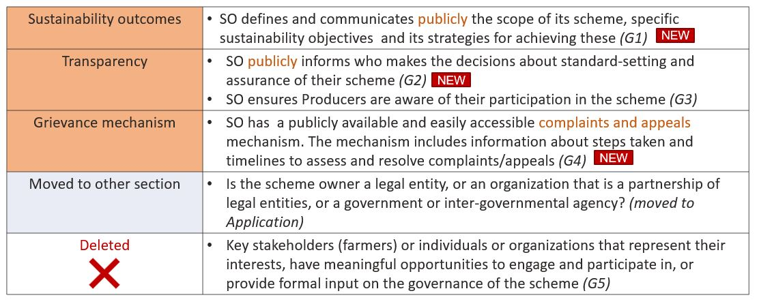

NEW

NEW

1. On a scale of 1 to 5 how much do you agree with the changes in the governance section?

5 (Strongly agree)

4

3

2

1 (Strongly disagree)

Are there requirements that are missing and/or should be strengthened in this section? Please elaborate with suggestions, questions or concerns.

**Standard-setting**

The goal of the standard-setting section is that the Scheme Owner develops standards that are relevant and transparent and that reflect a balance of stakeholder interests.

Standard-setting criteria were not updated in version EM 1.2 due to the need for further consultation. Changes to this section are therefore presented using EM 1.1 as starting point.

Figure 2 presents an outline of the criteria in the standard-setting section, highlighting:

1. New criteria
2. Criteria that are proposed to be deleted

New criteria aim to increase transparency of the scheme towards the general public on:

* the content of the sustainability criteria of the scheme;
* the opportunity for stakeholders affected by the sustainability criteria to participate in standard setting;
* the need for Scheme Owners to develop adequate guidance to support consistent interpretation of its requirements.

Criteria proposed to be deleted are considered as not key differentiators for credible schemes or not adding value. For detailed rationale on each of the changes see the [excel file](https://www.globalcoffeeplatform.org/wp-content/uploads/2022/03/GCP-EM-2.0-Operational-Criteria-DRAFT.xlsx).

Figure 2- Changes to Standard-setting

1. On a scale of 1 to 5 how much do you agree with the changes in the standard-setting section?

5 (Strongly agree)

4

3

2

1 (Strongly disagree)

Are there requirements that are missing and/or should be strengthened in this section? Please elaborate with suggestions, questions or concerns.

**Assurance**

The goal of the assurance section is that the Scheme Owner has a documented methodology for assessing compliance with its sustainability requirements so that supply chain partners, investors and other stakeholders know that they can trust the results of the assessments as being accurate, consistent, rigorous and accessible.

Changes to the section are presented taking as reference the version EM 1.2.

Figure 3 presents an outline of the criteria in the assurance section, highlighting:

1. New criteria
2. Criteria moved to other sections
3. Criteria that are proposed to be deleted

New criteria aim to cover the topic of competences of assurance providers and auditors, and exceptions. Criteria proposed to be deleted are covered in other requirements or are not considered key differentiators for credible schemes or would imply disclosure of confidential or sensitive information of farmers. For detailed rationale on each of the changes see the [excel file](https://www.globalcoffeeplatform.org/wp-content/uploads/2022/03/GCP-EM-2.0-Operational-Criteria-DRAFT.xlsx).

Figure 3- Changes to Assurance

|  |  |  |  |
| --- | --- | --- | --- |
| Fit for purpose | * The SO defines its assurance structure and activities commensurate with the scope of the scheme, risks inherent in its scope of operation, type of data collected, and end uses of the scheme, including the types of claims being made. * An overview of the assurance structure and activities is public. *(A1)* | | |
| Assessment Methodology | The SO has a defined assessment methodology to ensure consistent compliance with the scheme sustainability criteria, this includes:   * sampling methodology and frequency that assurance providers/evaluators are required to follow during the audit. * a documented risk management protocol to assess the risk level of clients or assurance providers and the resulting assessment frequency and intensity. * In the case of continuous improvement requirements, there is a documented methodology of how progress is monitored and verified*. (A2)* | | |
| Assurance Providers / Auditors’ Competences | * The SO has a defined process for reviewing the performance of assurance providers and auditors in conducting the assessment. This includes a review of the performance of assurance providers and auditors in conducting the assessment. *(A3)*   NEW | | |
| Remediation | * SO has a remediation policy/protocol in the case a non-conformity is found *(A4)* | | |
| Group assessment | * If the SO allows for group assessments, assurance providers/evaluators evaluate group internal management systems for efficacy in addressing non-conformities, including a clearly defined process for how group administrator(s) is/are addressing nonconformities for individual farms in the group *(A5)* | | |
| Exceptions | * SO has a procedure for determining and evaluating proposed exceptions to the standard or assessment process. Includes time-bounds for the exception *(A6)*   NEW | | |
| Impartiality and Conflicts of interest | * SO has a policy/procedure to identify, manage and monitor impartiality and conflicts of interest within its assurance system *(A7)* | | |
| Chain of Custody | * SO has a documented description of the required chain of custody model and of the mechanisms to ensure credible claims (A8) | | |
| Traceability | * If any claims are associated with the scheme, SO has a documented system for traceability to verify the history, location of assured product throughout the supply chain in order to protect and monitor the integrity of claims (A9) | | |
| Moved to other sections | Information on participation of farmers in the scheme  (Moved to Governance) | Information on sharing results of assessments to farmers  (Moved to Data) | SO provides public access data in an anonymous or aggregate report and/or a summary of key findings – *(Reframed under Data)* |
| Deleted  Close with solid fill | * SO has a procedure to identify risks, create plan to address and Act on the plan (Assess and Remedy). Or pass/fail compliance approach. In the case of continuous improvement approach, documented methodology of how progress monitored and verified. * Scheme Owner requires that a list of assessed entities is publicly available or at a minimum access for relevant stakeholders. * SO makes assessed/verified/audited data available * SO ensures stakeholders have the ability to review audit reports to ensure the scheme is reliable. | | |

1. On a scale of 1 to 5 how much do you agree with the changes in the assurance section?

5 (Strongly agree)

4

3

2

1 (Strongly disagree)

Are there requirements that are missing and/or should be strengthened in this section? Please elaborate with suggestions, questions or concerns.

**Data**

The goal of the data section is that the Scheme Owner manages data to ensure it is relevant and accurate for monitoring the performance and impact of the scheme

Changes to the section are presented taking as reference the version EM 1.2.

Figure 4 presents an outline of the criteria in the data section, highlighting one new criterion and criteria proposed to be deleted. The new criterion requires a M&E system that includes Key Performance Indicators or impact metrics. Criteria proposed to be deleted are not considered key differentiators for credible schemes. For detailed rationale on each of the changes see the [excel file](https://www.globalcoffeeplatform.org/wp-content/uploads/2022/03/GCP-EM-2.0-Operational-Criteria-DRAFT.xlsx).

Figure 4- Changes to Data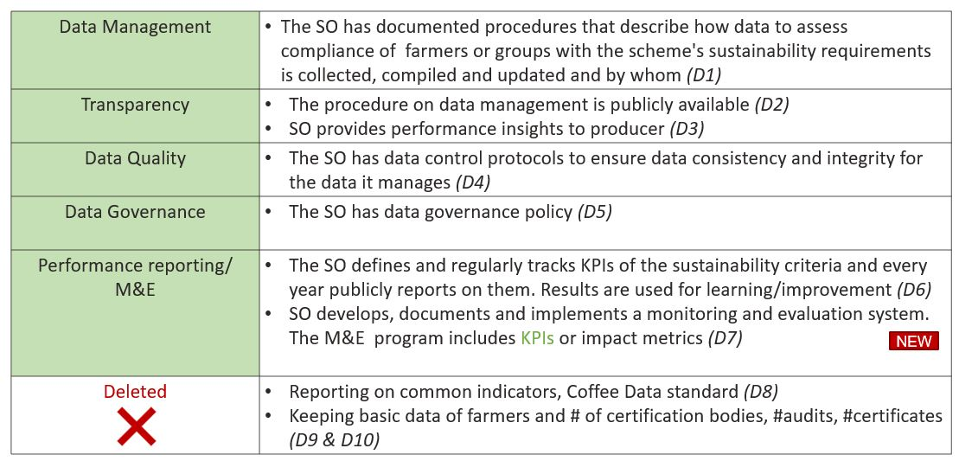

1. On a scale of 1 to 5 how much do you agree with the changes in the data section?

5 (Strongly agree)

4

3

2

1 (Strongly disagree)

Are there requirements that are missing and/or should be strengthened in this section? Please elaborate with suggestions, questions or concerns.

**Claims**

The goal of the claims section is that the Scheme Owner defines how and which claims can be made by producers and downstream actors in their program with respect to their sustainability performance. Claims about the scheme are consistent with its objectives, scope and level of assurance.

There are no significant changes to the claims section but suggestions to simplify and be clearer.

Figure 5 presents an outline of the criteria in the claims section.

Figure 5- Operational Criteria on Claims Table

Description automatically generated with medium confidence

1. On a scale of 1 to 5 how much do you agree with the criteria in the Claims section?

5 (Strongly agree)

4

3

2

1 (Strongly disagree)

Are there requirements that are missing and/or should be strengthened in this section? Please elaborate with suggestions, questions or concerns.

**Reporting to GCP**

This section outlines the reporting requirements for the Scheme Owners. It includes:

* The GCP recognition of a scheme as equivalent to the Coffee SR Code is valid for 3 years.
* Changes in the Equivalence Mechanism Sustainability Criteria (i.e. Coffee SR Code) or Operational Criteria before the end of the 3-year cycle may trigger an earlier re-assessment.
* Scheme Owners are required to confirm to GCP each year if there are no changes or notifying changes in their schemes (sustainability criteria and/or operational criteria).
* The Scheme Owner of a GCP recognized scheme is required to inform the GCP Secretariat in writing about significant changes or updates to its scheme or plans for revision of their sustainability or operational criteria.
* Significant changes include changes to its governance or ownership, management system, standard, or normative documents, which could compromise the scheme’s recognition by GCP. GCP will assess if the changes are substantive and require a re-assessment. Significant Changes to the Scheme are to be reported to GCP immediately and may trigger a re-assessment.
* The following data points are to be provided annually by the Scheme Owner:
  + Key figures (# farmers (female and male), # smallholders (<5 hectares or <10 hectares in Brazil), # total hectares, #bags (60 kg) # workers (permanent/temporary, female/male).
  + Performance reporting (see D6 on definition, monitoring and publication of KPIs)

1. On a scale of 1 to 5 how much do you agree with the proposal on the reporting to GCP?

5 (Strongly agree)

4

3

2

1 (Strongly disagree)

Are there any elements that are missing and/or should be strengthened in this section? Please elaborate with suggestions, questions or concerns.

1. **General Questions**

This section of the survey addresses general questions to changes in the Equivalence Mechanism v2.0.

**Transparency**

Under the different sections, there are different elements that the Scheme Owner needs to make publicly available. The following is the list of elements that is required to be made public by Scheme Owner per section.

1. On a scale of 1 to 5 how much do you agree with the proposed list of elements to be made public?

5 (Strongly agree)

4

3

2

1 (Strongly disagree)

Are there any other elements that you think is important that the Scheme Owner makes publicly available?

**Transition Period**

The revised version of the Equivalence Mechanism v2.0 will be valid from the moment of publication onwards (Q4 2022).

All schemes recognized prior to that date would have six months to align their schemes with the Coffee SR Code and the revised Operational Criteria (i.e. align their schemes with the EM v2.0) and to go through the equivalence process.

1. Do you agree with this transition period?

Yes

No

I am unsure

If you do not agree with this transition period, what is your suggestion?

**Objective of the EM revision**

One of the main objectives of the Equivalence Mechanism revision is to review and revise the Operational Criteria to reflect current good practice and users’ expectations of credible schemes.

1. Do you think that the DRAFT EM v2.0 proposal achieves this objective?

Yes

No

I am unsure

Please elaborate with suggestions, questions or concerns:

1. **Additional comments**

Please include in this space any other general additional comments. If you are referring to a particular criterion please include the letter and the number.

1. Do you have any other general additional comments to the revised Operational Criteria?

If you wish to provide detailed feedback, please fill the column for comments [in this file](https://www.globalcoffeeplatform.org/wp-content/uploads/2022/03/GCP-EM-2.0-Operational-Criteria-DRAFT.xlsx) and send it back to [info@globalcoffeeplatform.org](mailto:info@globalcoffeeplatform.org)

**Thank you for your valuable input and taking the time to complete this survey!**